Dragons
You will be supplied with a jacket and wings.
Please supply: Black t-shirt and black leggings/trousers. Black boot covers for girls. ALSO BLACK GLOVES

Hair: For girls please put in French plait if hair is long.

Make up: You will need to wear moisturiser and a dark foundation and go to make up

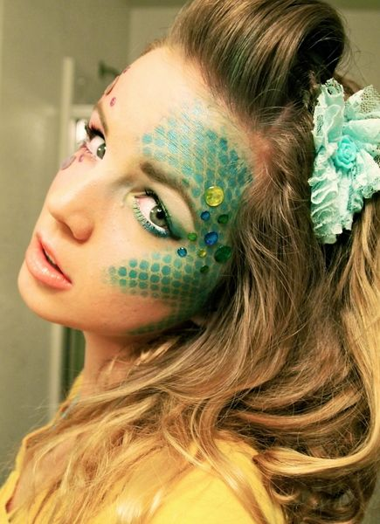
Make up

