Thorns

You will be supplied with a red vest top and black lace top to wear over the red, and a selection of red and black material you can use in your hair or pin to your leggings / shorts.
Please supply 1 pair of black shorts (you can stud these if you like) and black Fishnet Tights or black leggings which you can also slash if you would like to.
Black boot covers
Hair Wild & messy back combed hair, lacquered into place.
Make up Please apply foundation applied (2 tones darker than normal). GOTHIC - Grey/black eyeshadow, smoky eyes, black eyeliner and red full lips.
Accessories Feel free to add chains, bracelets chokers if you want. But please make sure these will not come off on the ice
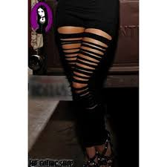
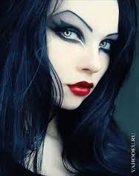
Some suggestions:
